Artist Recognition
from Audio Features of Songs
An attempt to analyse some portion of
Million Song Dataset


V 0.1 12.06.2015 Initial Draft

Project Team
Arulselvan Madhavan
Yogendra Miraje
Ameya Pandilwar

Table of Contents
1 Introduction 3
1.1 Problem Statement 3
1.2 Dataset Information 3
2 Approach to solve the problem 4
2.1 Data Preparation 4
2.2 Applying Machine Learning 4
2.3 Technology Stack 4
2.4 Cloud Platform 4
3 Solution 5
3.1 Data Parsing and Loading 5
3.2 Test and Train Data Preparation 5
3.3 Modelling 5
3.4 Evaluation 5
4 Results 6
5 Conclusion 6
References 7

Introduction
Science behind the music has been a topic of serious research recently. Analysing the huge data about songs and music composed for over a century is an exciting big-data topic and can provide some very interesting insights that have never been looked at before.

Problem Statement
The problem that we are trying to solve is finding out how accurately we can predict the artist of a song from the audio features of the songs specifically timbre of the song.
The dataset we are using is ‘Million Song dataset’ (MSD) that contains metadata about 1 million songs prepared through collaboration of Columbia University and The Echo Nest.

Dataset Information
MSD has 273 GB of data comprising of 1 million songs/files(since 1922) from 44, 745 unique artists. The data is in HDF5 format.
The dataset has 42 features for each song. You may find all the features at http://labrosa.ee.columbia.edu/millionsong/pages/example-track-description
The Key features for our analysis are given below.
Column Name | DataType | Description
Artist Id | String | ID of the Artist in the ECHO Nest database
Song Id | String | ID of the song in the ECHO Nest database
Timbre | 2D Array of Float | Texture features of the song.
Year | int | The year in which the song was released.

The timbre feature is a vector that includes 12 unbounded values roughly centred around 0. Those values are high-level abstractions of the spectral surface, ordered by degree of importance. The first dimension represents the average loudness of the segment; second emphasizes brightness; third is more closely correlated to the flatness of a sound; fourth to sounds with a stronger attack; etc. After extraction of timbre data, we get 12 average values over the hundreds of segments of the song and 78 co-variances. We have added the released year of the song as a feature, Thus, for each song, we have 91[12 + 78+ 1] features.

Approach to solve the problem
The very first step towards analysing the data is to store this data in some readable and understandable format. So, we parsed the complete dataset, extracted the key features required and loaded them into database. Once we had access to the key features, we simultaneously started working on test and train data preparation and exploring different machine algorithm that can satisfy our requirement and also give some acceptable prediction accuracy. While choosing the version for Softwares used, we ensured inter-compatibility of versions for different technologies used and also

Data Preparation
We parsed the dataset using Python and loaded the key features into HBase. For preparing test and train data we choose the songs only from the artists with 50 or more than songs. This way we could ensure good training data for our model. For any such artist, we have one song in the test dataset and remaining songs in the training dataset.

Applying Machine Learning
We explored different machine learning algorithm like K-nearest neighbours, PCA, Regression and out of that we found classification Logistic Regression algorithm is best suitable for our problem. The different classes/ labels are artists. We will train our model based on the 90 timbre values and year and with the label as artist. Model will predict the artist for the entire sample in test dataset. We will use some visualization tools to check accuracy of the model and finding some interesting patterns.

Technology Stack
- Hadoop 2.6
- Hbase 0.98.15
- Anaconda Python 2.7
- Thrift 0.9.3
- Spark - 1.5.0
- Scala 2.10

Cloud Platform
- AWS – EC2

Solution
The solution to the problem is divided into four major tasks. Below is the block diagram to show these tasks.
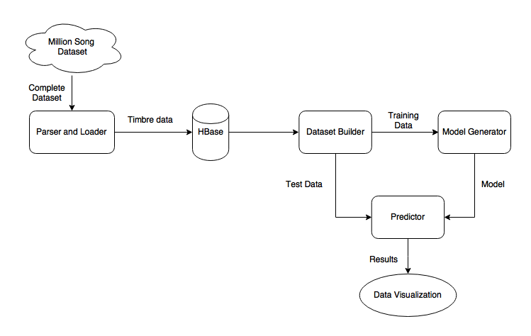
Fig. 3.1 Block diagram showing major components in the solution

Data Parsing and Loading

Test and Train Data Preparation

Modelling

Evaluation

Results

Conclusion

References

